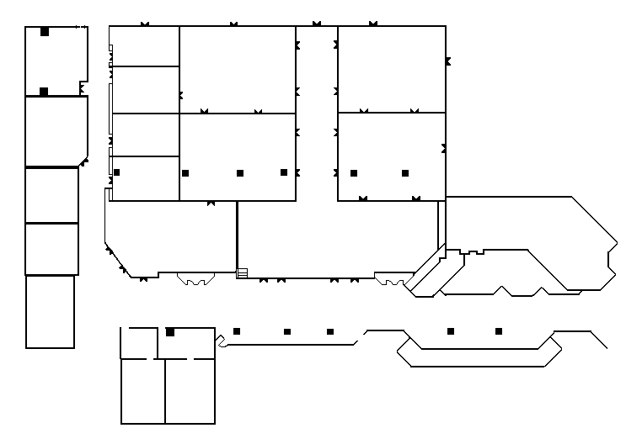 Plaza Hotel Triple Crown Ballroom-3rd Floor
Dec 14
5pm - Early Registration located between the elevators & TCBR 10.
Dec 15 - 16
Regular Registration, Meetings, and Reception in Jockey Club Rooms 1 and 2.
Dec 15
Sponsored Luncheon and Awards at Main Street Station Hotel & Casino’s Garden Court Buffet 800-713-8933 (a short walk).

TCBR 2 25” C
Jockey 25’ 44’ O 44’
Club #2 TCBR 6 R TCBR 8
TCBR 3 24’ R
I
25’ 62’ D 59’
O
Jockey TCBR 4 20’ R
Club #1 25’ TCBR 7 48’ TCBR 9 48’

TCBR 5 28’

25’ 62’ 59’
Garage
Elevator
Turf club
South TCBR 10 34’ TCBR 11 36’
Tower
Elevators 59’ 99’
BAR
→ EARLYREGISTRATION AREA ←

Catering
Office

MEN WOMEN

